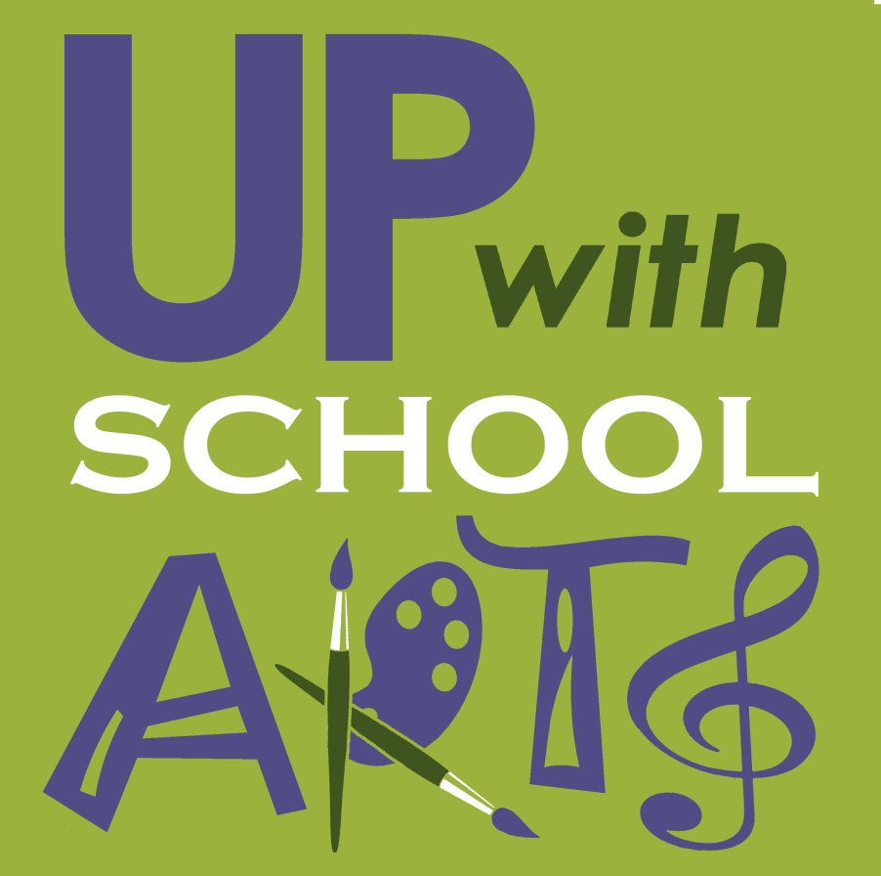

Up With School Arts
Sponsorship Application Form

Applicant’s Name: _____________________ School: _______________________

Grade/Class Taught: ______________________ Subject:__________________________

Phone: ______________________________ Email:____________________________

Program Title: ______________________ Amount Requested: __________

Number of students participating: ___________ Date of program: __________

Subject: Music/Art/ELA etc.: _____________________________________________________

Class/Grade that will benefit: _____________________________________________________

Summary of Sponsorship Request/Program: ________________________________________________________________________________________________________________________________________________________________________________________________________________________________________________________________________________________________________________________
Continue on back if necessary. Include (i.e. pamphlets, programs, website links, etc.)

Outcome/Goal of Sponsorship/Program:________________________________________________________________________________________________________________________________________________________________________________________________________________________

Requirements for sponsorship include:
- Provide public acknowledgement of Up with School Arts sponsorship when publicizing/promoting this event.
- Complete the post-program questionnaire that follows this request

Signature of Applicant:__________________________ Date:______________

Signature of School Principal:_____________________ Date:______________

PLEASE MAIL TO: Up with School Arts, P.O. Box 204, Little Compton, RI 02837

Up With School Arts
Post-Program Questionnaire

- Did the activity meet your expectations? Why or why not? Will you repeat the activity in the future?
________________________________________________________________
________________________________________________________________
________________________________________________________________
- How were you able to tie the activity to the curriculum? Did this enhance the students’ ability to learn and absorb the material? What were the students’ reactions to the activity?
________________________________________________________________
________________________________________________________________
________________________________________________________________
________________________________________________________________
- How can Up With School Arts help you enhance learning activities in your school system? What areas do you need support in?
________________________________________________________________
________________________________________________________________
________________________________________________________________
- Please critique our grant application and delivery process.
________________________________________________________________
________________________________________________________________
________________________________________________________________
PLEASE MAIL TO: Up with School Arts, P.O. Box 204, Little Compton, RI 02837

